MRI (Magnetic Resonance Imaging) scanners utilize a technique involving strong magnetic fields, radio waves, and field gradients to project beams through the desired object and the data returns in the form of a plot of the Radon transform, otherwise known as a sinogram. This is extracted from the following applicable equation of the Radon transform:



(theta represents angle of lines, and r the perpendicular offset)

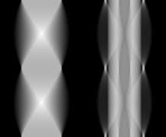

**Example sinogram produced by Radon transform on an object**

To reconstruct an image from the sinogram that has been created, we must perform an Inverse Radon Transform on the image. The technique employed for our project involved using the filtered back projection technique, which is an algorithm built into the Matlab iradon function for our intents and purposes, in order for this reconstruction of the projection data to occur. This process is further broken down into two separate processes: projection and filtration.

Projection is very similar to Radon but the line integrals are projected back onto the plane at their respective angles. The projection phase equation of the Filtered Back Projection, where f’ is the filtered data.



The common discrete approximation of this is

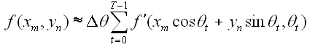

This equation is used to determine the pixel values at any given point where the exact values are dependent on the chosen interpolation method. As we added more projections the quality of our reconstruction increased.

Figure 1 (No Filter) Figure 2 (Shepp-Logan)

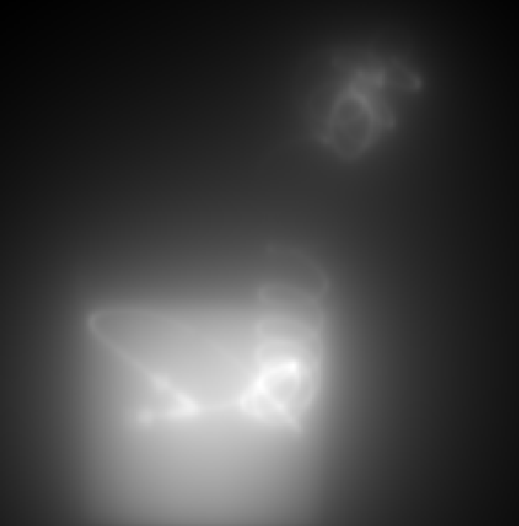 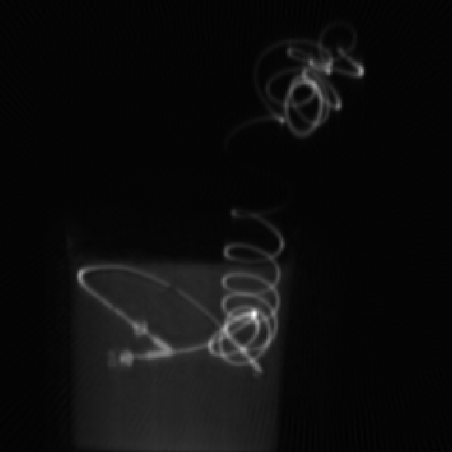

Using filtration we were able to filter out the blurred reconstruction from Figure 1 to get the clear image in Figure 2. We found that the Shepp Logan filter was the best filter for our reconstruction. The Shepp-Logan filter multiplies the Ram-Lak filter by a sinc function. The Ram-Lak filter is also known as the Ramp filter. This filter is sensitive to noise so it is multiplied by a suitable window to improve the results. The Shepp-Logan filters are high pass filters which allows the the edges information to stay in tact, giving the nice sharp image you see in Figure 2.